Steps to create a user with the endpoint

To create a new user you must follow the steps below:

- You will use the following POST endpoint https://api.treez.io/v2.0/dispensary/[dispensary_name]/customer/detailcustomer

- The body of the request will have the following structure:
{
"first_name": "Test",
"last_name": "Treez",
"birthday": "1988-08-06"
}

It is worth mentioning that these are the minimum data that the body must have, the fields "first_name", "last_name" and "birthday" are required and mandatory when creating a new user.

Also in the Treez documentation we can find that these fields are required

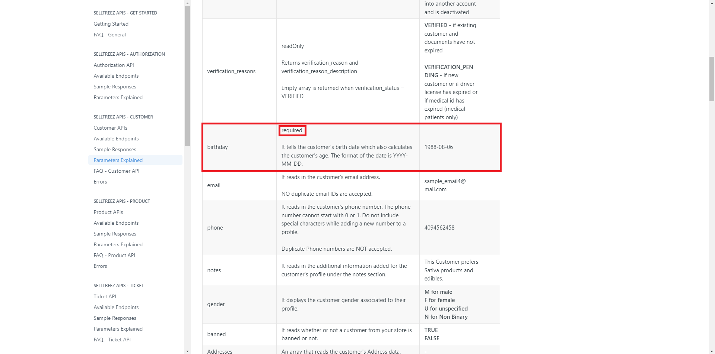
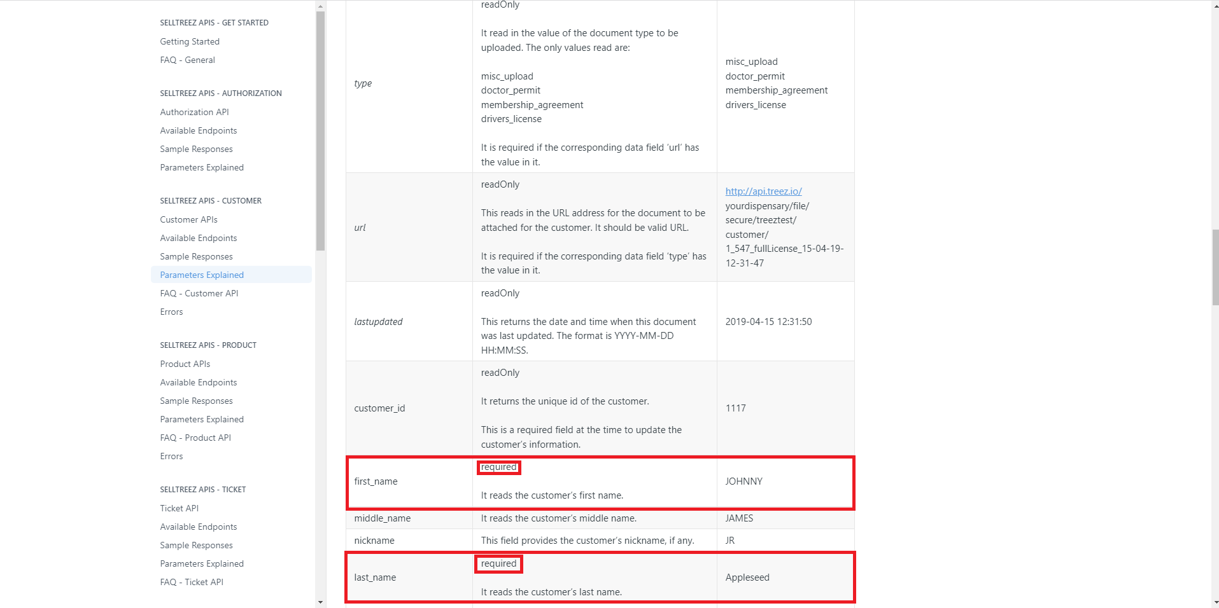

- When you have made the request you will get the following response indicating that the user has been successfully created
{
"resultCode": "SUCCESS",
"resultReason": null,
"resultDetail": null,
"data": {
"status": "ACTIVE",
"verification_status": "VERIFICATION_PENDING",
"verification_reasons": [
{
"verification_reason": "NEW",
"verification_reason_description": "NEW_INTAKE_CUSTOMER"
}
],
"customer_id": "35827",
"first_name": "Test",
"middle_name": null,
"nickname": null,
"last_name": "Treez",
"birthday": "1988-08-06",
"drivers_license": null,
"drivers_license_expiration": null,
"state_medical_id": "N/A",
"permit_expiration": "N/A",
"email": null,
"phone": null,
"notes": "N/A",
"physician_first_name": null,
"physician_last_name": null,
"physician_license": null,
"physician_address": null,
"physician_phone": null,
"is_caregiver": false,
"caregiver_license_number": "",
"caregiver_name_1": "N/A",
"caregiver_name_2": "N/A",
"caregiver_details": [],
"rewards_balance": 0,
"rewards_type": "POINTS",
"gender": "U",
"signup_date": "2023-08-29T12:48:04.000-07:00",
"last_visit_date": "2000-01-01 00:00:00.000",
"last_update": "2023-08-29T12:48:04.000-07:00",
"opt_out": "true",
"referral_source": null,
"banned": false,
"warning_1": false,
"warning_2": false,
"addresses": [],
"merged_customer_ids": [],
"merged_into_customer_id": null,
"patient_type": "ADULT",
"customer_groups": []
}
}


If we try to create a user in postman where any of the required fields mentioned above are missing then the following error will be returned

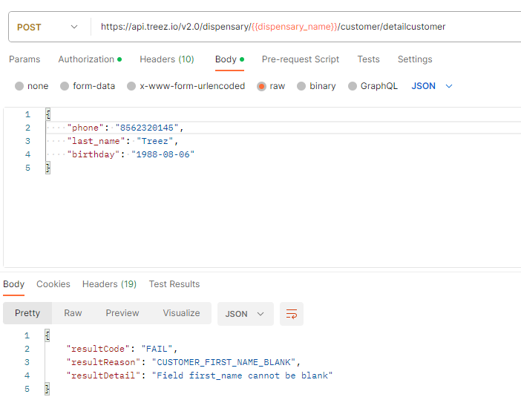

I tried to edit an existing user by deleting his first name, last name and birthday from the Treez Portal but it doesn't let me update it either, as you can see in the following images

